**GRBLMega328P-MU-V11**

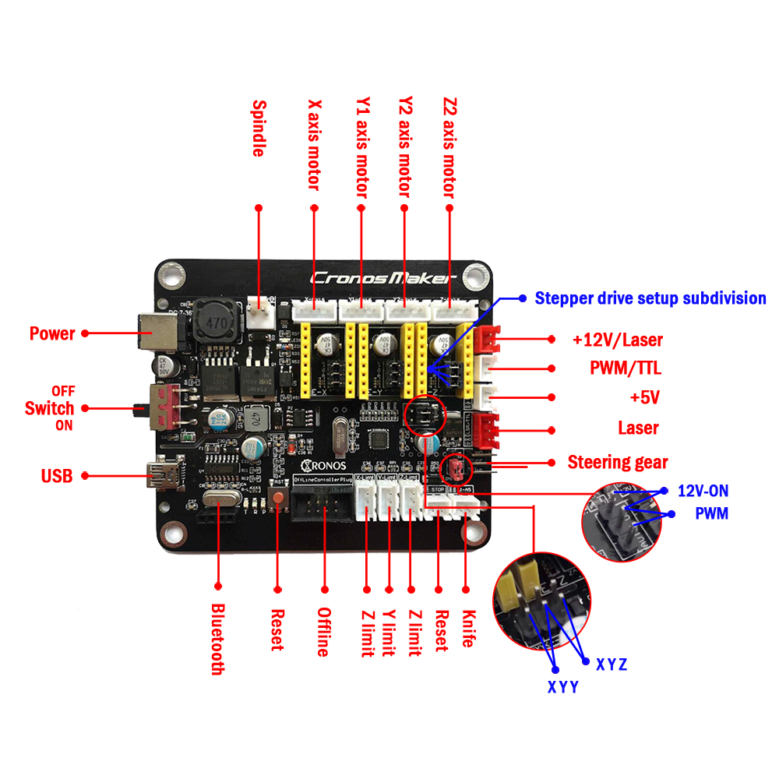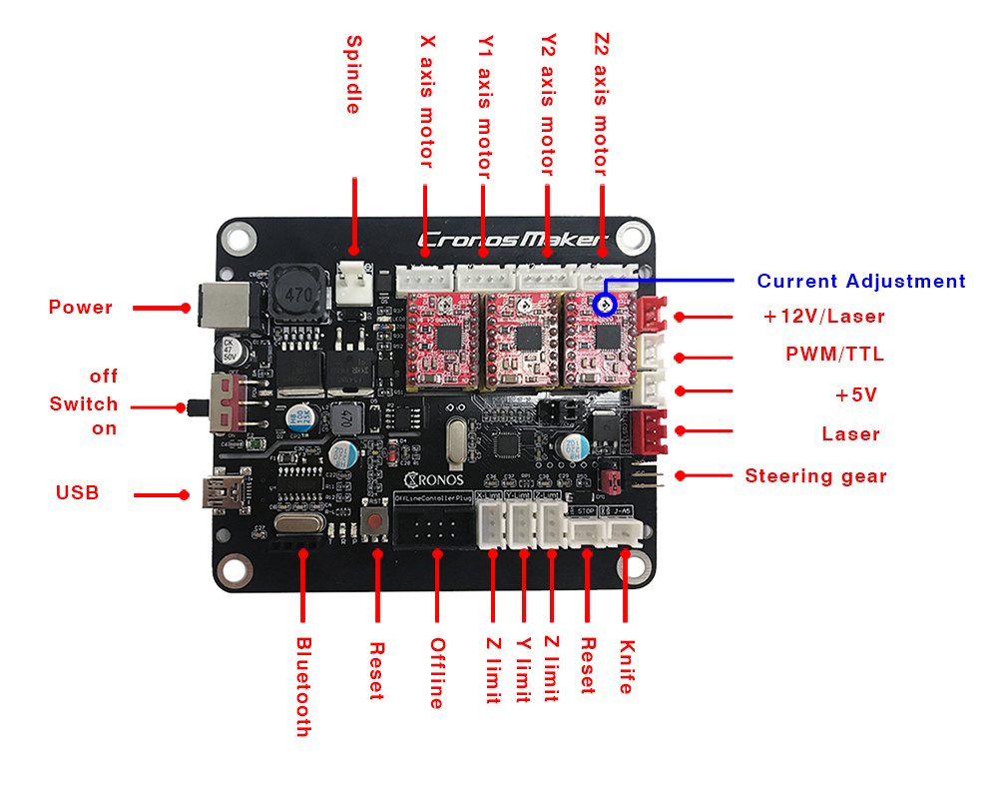

**All the settings in this document refer to the official instructions:**

**https://github.com/grbl/grbl/wiki/Configuring-Grbl-v0.9**

**1: Subdivision function use**

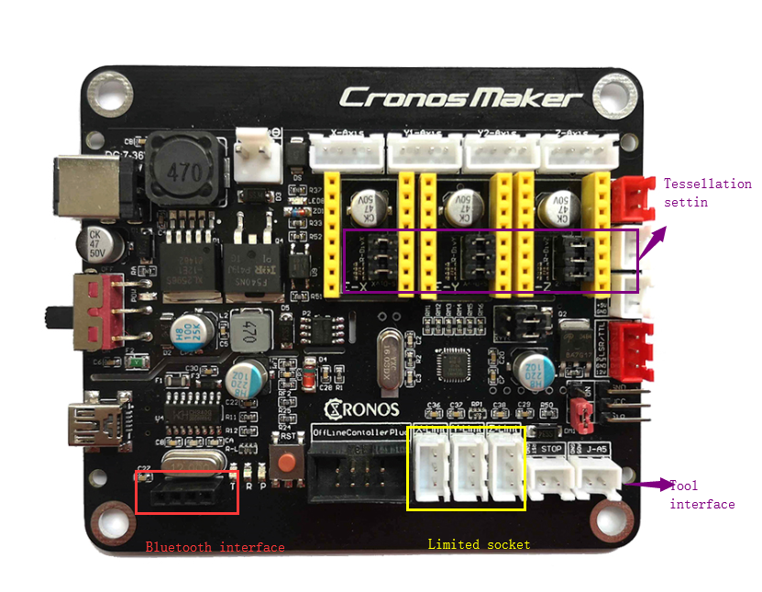

The three sets of jumper caps pointed by the blue arrow in the above figure are subdivided for the 4988 driver. The three groups from left to right correspond to the X-axis Y-axis and the Z-axis.

**Setting instructions:**

As shown in the figure above, each set of shorting caps from top to bottom is: MS3, MS2, MS1.

Refer to the figure below for the subdivision settings.

There are also three mode selection terminals MS1, MS2, MS3. We are all grounded, that is, full step mode (200 steps or one step 1.80). If higher precision is required, we can choose Other modes, such as if we choose 1/4 step mode, then we need to send 800 microsteps to complete the motor.

Let me take a look at the relationship between mode selection and MS1, MS2, MS3:

Note: The jumper cap is H.

The jumper cap is pulled out.

**Interface of A4988:**

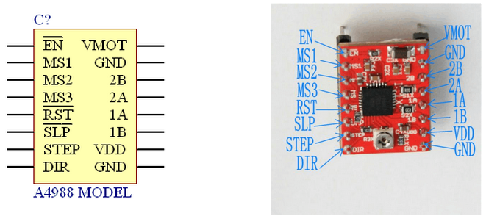

**2: Bluetooth usage and matching solutions**

Important note: Please use the HC series Bluetooth and Windows operating system computer for Bluetooth (others are not tested, you can study it yourself). Please let the seller set the communication baud rate to 115200 when purchasing. (Bluetooth's own baud rate, refer to the Bluetooth manual configuration. HC series Bluetooth is set by the AT command, the operation method is more professional, it is recommended to buy the Bluetooth module at the same time when purchasing the motherboard), no check, 1 stop position.

HC-05, HC-06, HC-08, etc., Bluetooth to serial port (TTL level) modules are available.



As shown above, the socket in the red circle is a Bluetooth socket.

Installation method legend 1: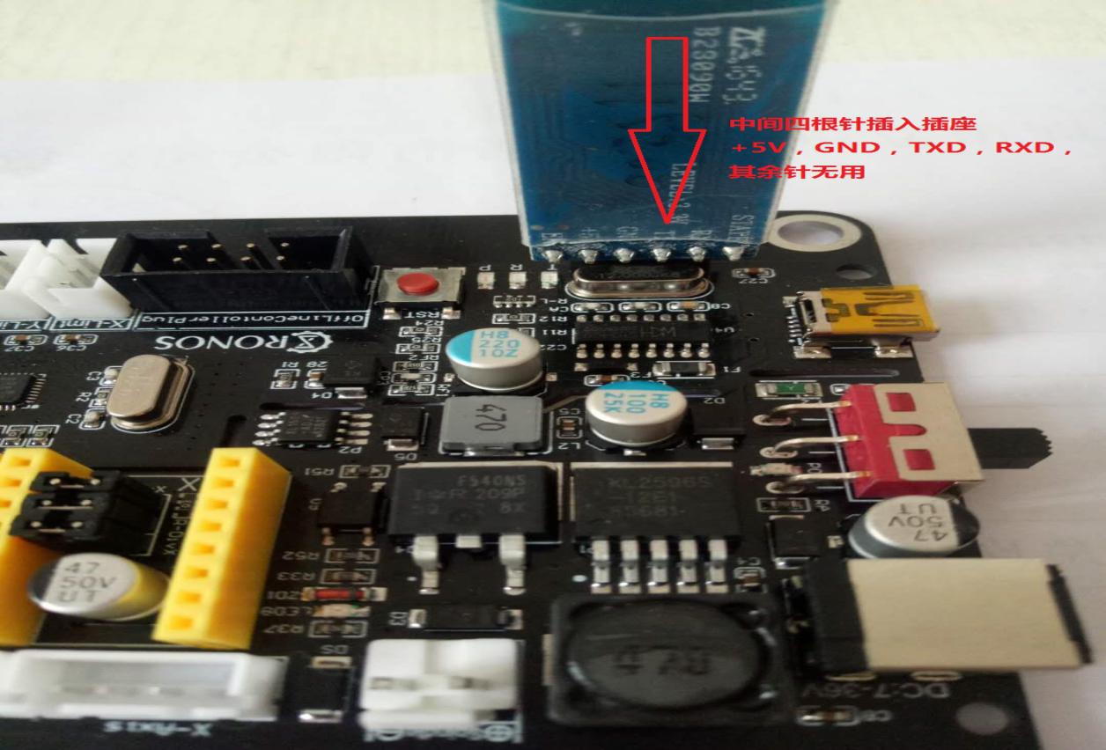

Installation method legend 2:

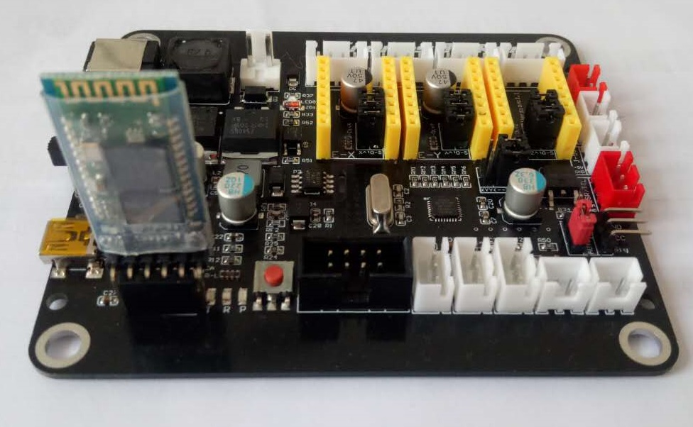

After the wiring is confirmed, the motherboard is powered. The Bluetooth is paired with the Bluetooth via the computer. The pairing password is 0000 or 1234. Please refer to the official document of CH-05 Bluetooth.

After the pairing is successful, the computer will virtualize two serial ports. By right-clicking on my computer, the device manager will view the virtual serial port. One of the two serial ports is actually usable, and the user needs to try twice.

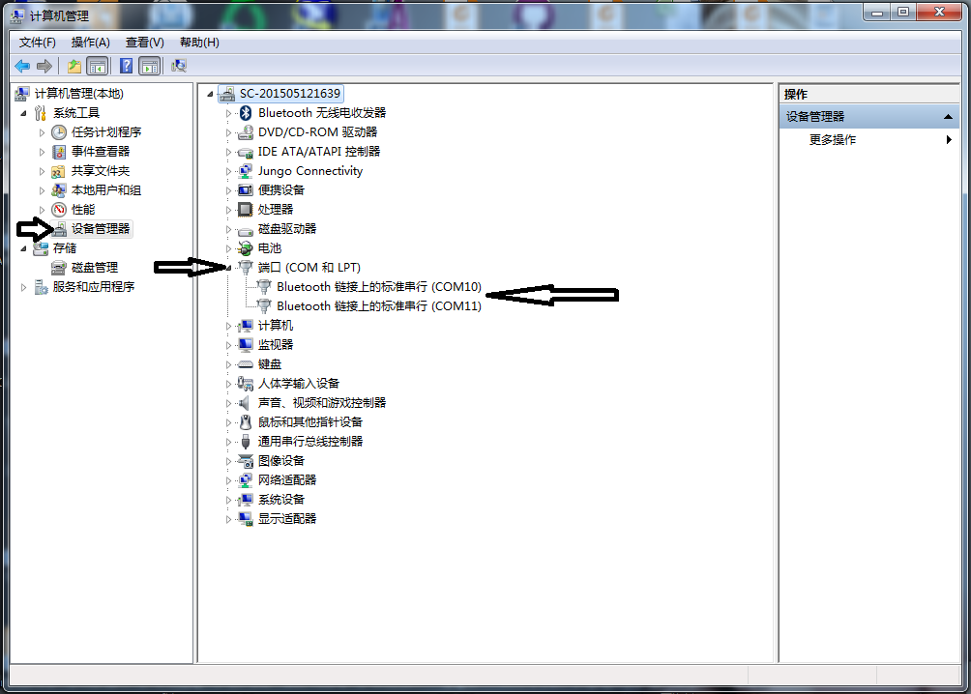

After the serial port is confirmed, it can be connected to the motherboard for engraving, laser engraving, or writing, just like the previous connection of the USB data cable.

**3: How to use the limit switch**



In the yellow circle, there are three axis limit sockets, and the three groups from left to right correspond to the X-axis Y-axis and the Z-axis.

Signal description: each socket from top to bottom: +5V, GND, limit signal line

On the limit hardware, the signal line and the ground line (GND) are connected. The limit is used. After the limit is used, the engraving machine board is connected to the computer and the limit setting is set by setting:

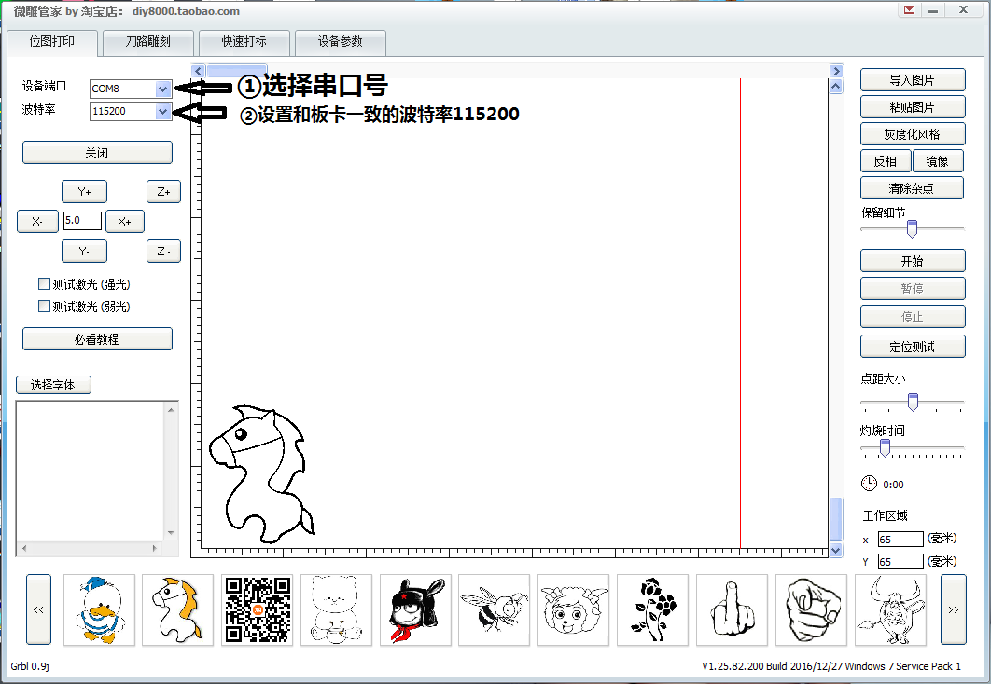

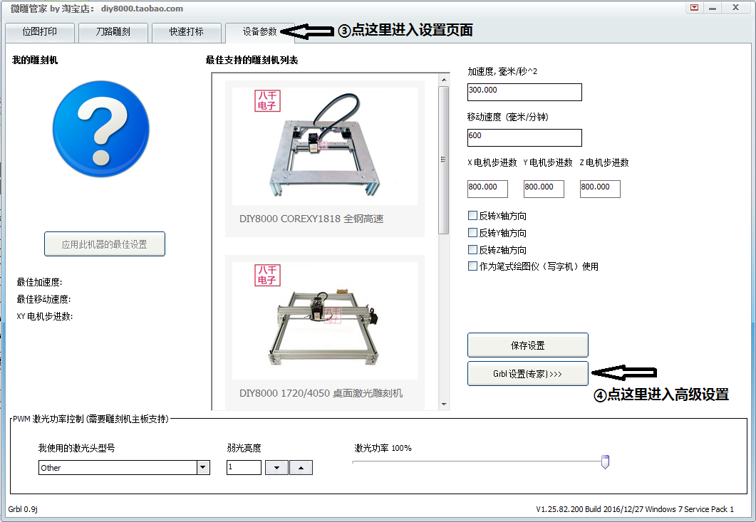

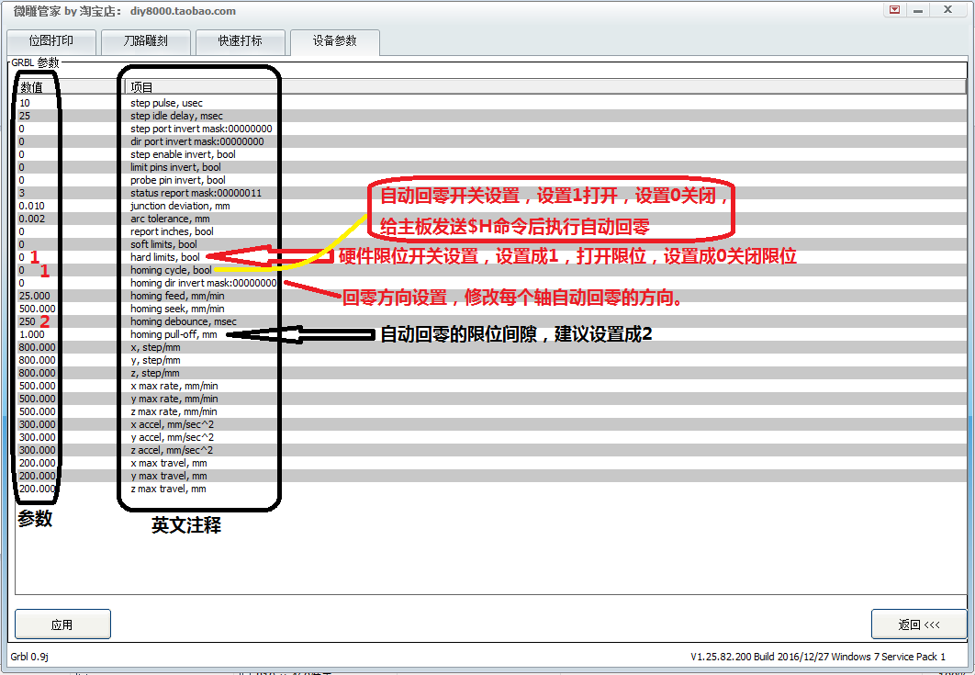

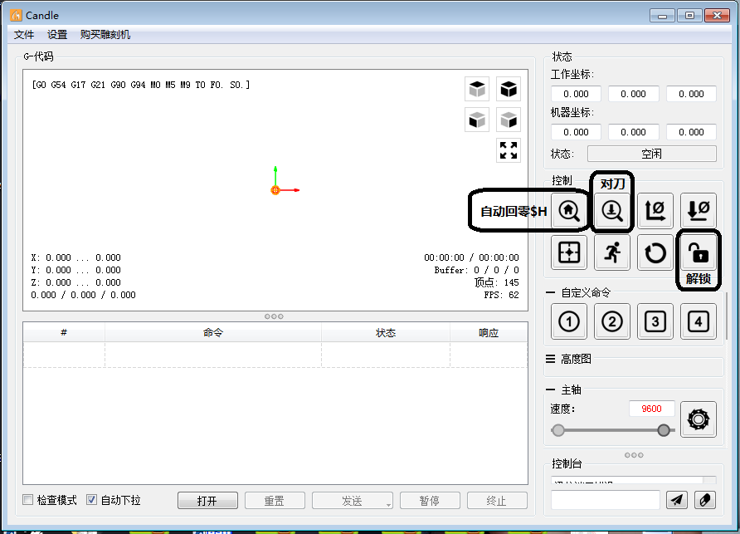

The setting of automatic zero return needs to understand the correspondence between binary and binary to decimal. It is more complicated. It is recommended for professional operation. For details, please refer to the official introduction:

**https://github.com/grbl/grbl/wiki/Configuring-Grbl-v0.9**

**$23 - Homing dir invert mask, intbinary**

By default, Grbl assumes your homing limit switches are in the positive direction, first moving the z-axis positive, then the x-y axes positive before trying to precisely locate machine zero by going backand forth slowly around the switch. If your machine has a limit switch in the negative direction, thehoming direction mask can invert the axes' direction. It works just like the step port invert and direction port invert masks, where all you have to do is send the value in the table to indicate what axes you want to invert and search for in the opposite direction.

**4: How to use the knife:**

Open the hardware limit,

Automatic zero return

The setting of the zero return direction is correct

The automatic clearance is set to 2



As shown in the figure, the two-core socket A5 is the tool-to-tool interface, AD5 is the signal line, clamped on the spindle, GND is the ground wire, connected to the frame, and the Z-axis is lowered after the tool-cutter command is sent until it hits the tool block. A5 is connected to GND and the board receives the signal.

The tool can be commanded G38 Z-xxx, or click the button shown below.



**5: Offline link description**

After offline connection to the motherboard through the cable, you can move or engrave the file with each axis through the offline module.

The computer will be invalid after the offline module is linked.

